Service Request: Multiple Device Repair Request

1. Click on ‘Remedyforce Self Service’:
2. Click on ‘Request a Service’ tile
3. Under category ‘Device Repair Service’, click ‘Multiple Device Repair Request’
4. Enter all the Required fields & attach Device Repair file.
5. Submit the Service Request.

Note: Device Request file needs to be attached to the Multiple Device Service Request. Device Request File should be in proper format.

Device Request File:

The file should be in Microsoft Excel format (.xlsx). The Excel file should have following fields.

* Serial Number, Repair Customer Name, Device Type, Device Description, Device Color, Problem Description, Warranty Claim, SR Number~, SR Id.
* Please make sure that SR Number~, SR Id fields are *<blank>* when you submit Service Request.



Once the Service Request is submitted, you will receive Service Request Number. MTech Staff will be the owner of the Service Request. Submitted Service Request can be opened in Remedyforce Console. MTech Staff will download the attached Device Request File. Staff will update the downloaded file by add data in 2 fields “SR Number~” & “SR Id”. Once the file is updated, MTech Staff can begin data upload process.

“SR Number~” & “SR Id” are mapped to following fields on the Service Request form.

* “SR Number~” <-> Name
* “SR Id” <-> Incident Id~

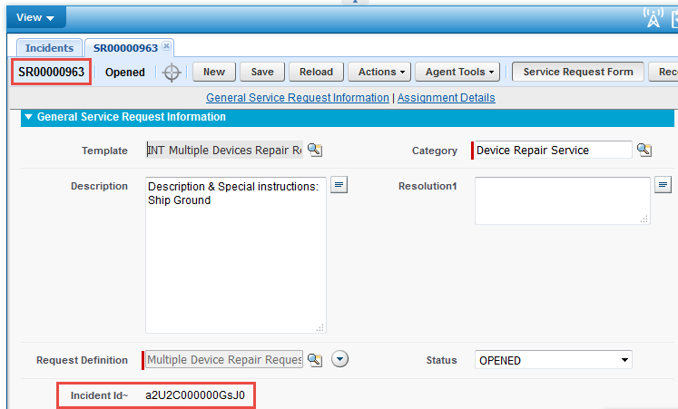

Data Import Process:

MTech Staff will be using Data Import Wizard. Please use following steps to import data into Remedyforce Object ‘MTech_Devices’.

Step 1: Start Data Import Wizard

* Data Management -> Data Import Wizard -> Launch Wizard

Step 2: What Kind of data are you importing?

* Select ‘Custom Objects’

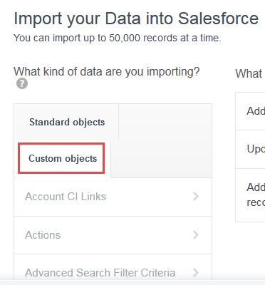

* Select “MTech_Devices”

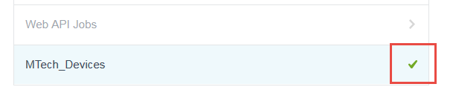

Step 3: What do you want to do?

* Select ‘Add new records’

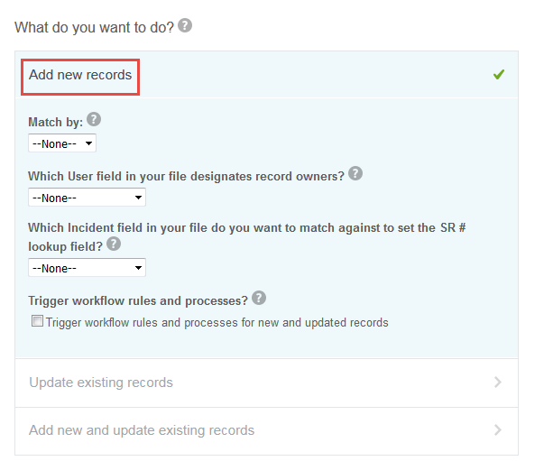

Step 4: Where is your data located?

* Browse and select file for data upload.
* Click Next.

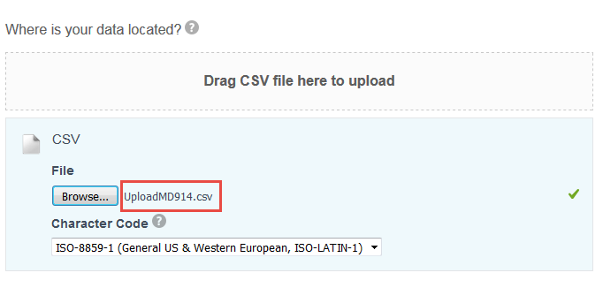

Step 5: Edit mapping: Please use following fields to map it to the fields in the upload file.

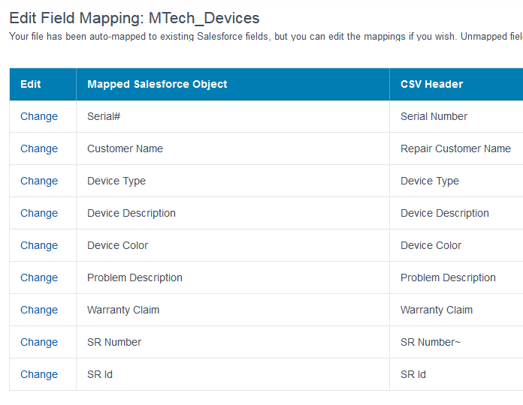

Step 6: Review & Start Import:

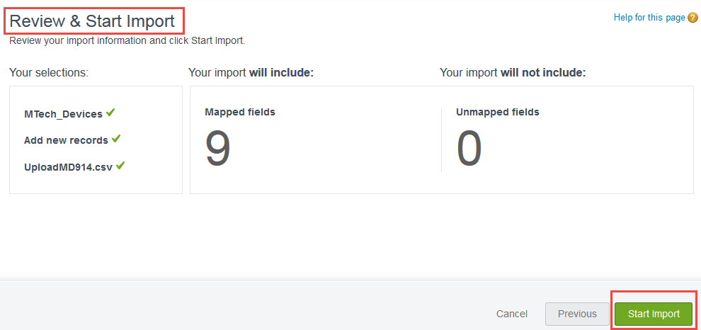

Once the data is imported, you can go to MTech_Devices tab to view all the imported data.

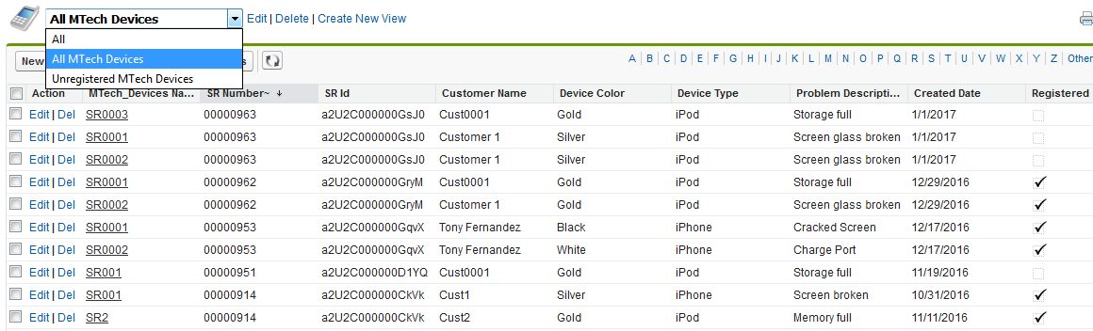

Note: Please make sure that SR Number~ & SR Id fields are populated.

In the above list, registered Devices will be marked with the checkbox in the field “Registered”

Device Synchronization Process:

* Click on button ‘Start Sync Process’

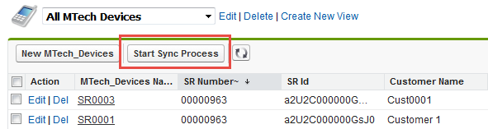

On Start Synching Process screen: Select the ‘Service Request#’

* You will only see the Service Requests for which Synchronization process not initiated.
* Once you select Service Request from dropdown, all the unregistered Devices will be listed as shown below.

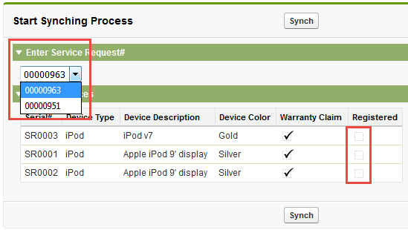

Click on ‘Sync’ button to begin Device Synchronization.

Once the Synchronization is complete, the repair devices will get registered in CMDB and the Tasks will be created in Service Request for each Device.